Tri-County Community Action Agency, Inc.
2020 Annual Report

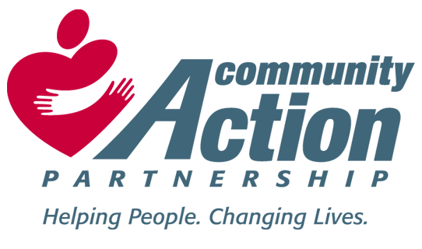
Tri-County Community Action Agency, Inc.
1015 Dispatchers Way
LaGrange, KY 40031
(502) 222-1349
FAX (502) 222-0968
www.tricountycaaky.org
info@tricountycaaky.org

MISSION STATEMENT:

TRI-COUNTY COMMUNITY ACTION EXISTS TO PROVIDE LEADERSHIP AND ADVOCACY; TO DEVELOP COMMUNITY-BASED COORDINATED SERVICES AND ACTIVITIES DESIGNED TO ENABLE LOW-INCOME/DISADVANTAGED PERSONS TO GAIN THE NECESSARY SKILLS, EDUCATION AND MOTIVATION TO BECOME SELF-SUFFICIENT.
CHANGING LIVES, CHANGING COMMUNITY
WHO WE ARE:
Tri-County Community Action Agency (TCCAA) is one of 23 community action programs in the state of Kentucky. The agency serves the core counties of Henry, Oldham and Trimble. TCCAA is part of a national movement created in 1964 with the passing of the Economic Opportunity Act. Community Action Agencies work on behalf of individuals and families to help them improve their daily living situations and to stabilize the family unit. Community Action is about real people: the individuals who volunteer time and money; the individuals and families who find a road out of poverty into self-sufficiency; and the agencies themselves whose dedicated staff encourage and inspire. Tri-County Community Action Agency provides a variety of services to clients over 60 years of age, to low-income clients and to at-risk families. TCCAA is incorporated as a private nonprofit 501(c)(3) agency and is governed by a volunteer board of directors. The agency has been providing services for more than 46 years and continuously strives to identify needs of the community and to develop services to meet those needs. Through our various program services we promote self-sufficiency and independent living, helping our customers to achieve their own success by focusing on the positive aspects of their lives.
PROMISE OF COMMUNITY ACTION:
Community Action changes people's lives, embodies the spirit of hope, improves communities, and makes America a better place to live. We care about the entire community, and we are dedicated to Helping People Help Themselves and each other.

Dear Friends,

One of the joys of preparing an annual report is that it gives us the opportunity to look back and be thankful for all that has been accomplished. The past year was filled with wonderful opportunities and many challenges. Some of the highlights were:

- Provided 42,486 congregate and home delivered meals to the elderly.

- Provided 42770 units of support services such as education, counseling, health promotion, advocacy, amongst many other components to 864 senior participants.

- Provided 14942 units of Homecare services such as personal care, homemaking, lawn mowing etc to the elderly to assist them to age in place.

- Provided 10392 units of Medical and Center Transportation.

- Provided 7590 units of respite through our Adult Day Care Center.

- Mobilized 5004 hours of volunteer time to enhance community services.

- Volunteers drove 7965 miles to ensure the needs of homebound senior citizens were met.

- Assisted 1552 households with direct client assistance of $273,331 to ensure heat within homes.

- Distributed $12000.00 in Wintercare/Winterhelp funds to ensure families retained vital services.

- Distributed $11,952. in Team KY funding to assist those affected by COVID 19.

- Distributed 10,000 worth of supplemental food through a Meals On Wheels grant.

- Distributed $10245 in Emergency Food and Shelter funds.

- $199,796 State and Federal funds to address and assist in self-sufficiency efforts.

- Distributed $15,021 in CSBG Cares to assist those affected by COVID 19.

- Weatherized homes of low-income clients to help lower energy costs utilizing $280,875 within the three county area.

- Provided 6,120 boxes of commodities and emergency food to families.

- Assisted 125 families/individuals with donated face masks.
- Through a partnership with Waterstep made and distributed 600 gallons of bleach.

- Through a partnership with Ashbourne Farms distributed 10,500 meals.

- Through a partnership with Ohio Valley United Charities provided 385 rides/deliveries to seniors within the Henry and Trimble County area.

- Through a partnership with Oldham County and Metro United Way we distributed $15,000 of COVID relief emergency relief funding in the community to assist with rent, food, water, electricity.

- Hosted monthly Alzheimer’s caregiver support groups.

- Home to numerous recovery support groups such as AA, NA, and Celebrate Recovery.

- Development of HOPE Center continues with the completion of small conference room, seven offices, new kitchen and appliances, file room, operational services and recovery support groups.

Complete financial audit report and 990 tax return is available online at www.tccaaky.org

Total revenue $1,894,941
Total expenses $1,635,892
Fundraising expense $0.00
Total Program expenses $1,541,325
Total Administrative expenses $94,567
Total ending net assets 1,070,545.

FY 2020 Board of Directors:
Judge Executive David Voegele – Board Chair | Judge Executive Brent- Vice Chair | Judge Executive Todd Pollock
Wayne Theiss | Melodye Fletcher - Secretary | Shane Courtney- Treasurer
Rick Lucas | Shawn Golden | Will McCoy
Bill Tucker | Scott Bates | Charles Callahan
Dotty Sparrow | Polly Troxell | Jane Proctor
Elsie Carter | Darlene Taylor | Kenneth Cottongim

Executive Director: Brenda Fox Chief Financial Officer: Debra Head

Tri-County Community Action Agency, Inc. is tax exempt under 501(c) (3) of the Internal Revenue Code. Donations are tax deductible to the extent allowed by law.

